Copy from Mater to other slave

1. Create 1 ec2 instance as Master

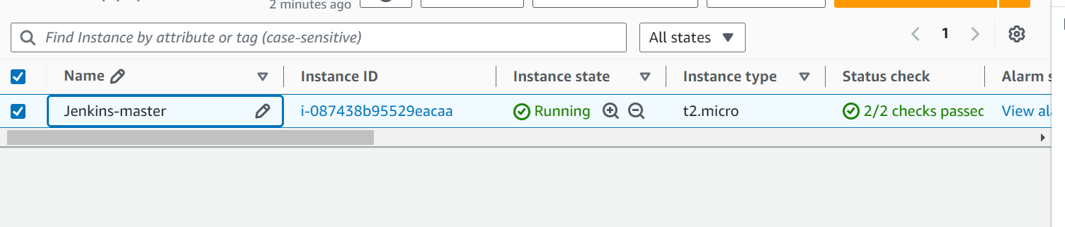

1. Install java

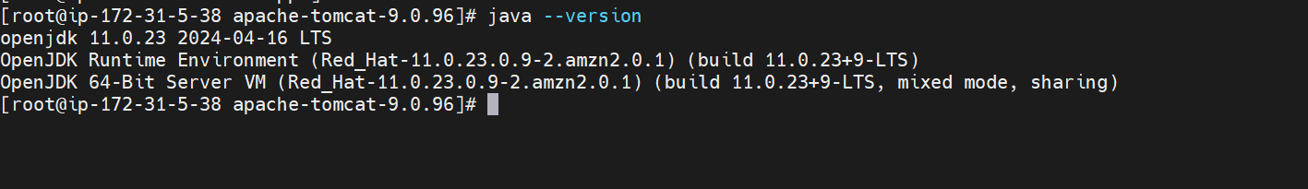

1. Install Jenkins as war application

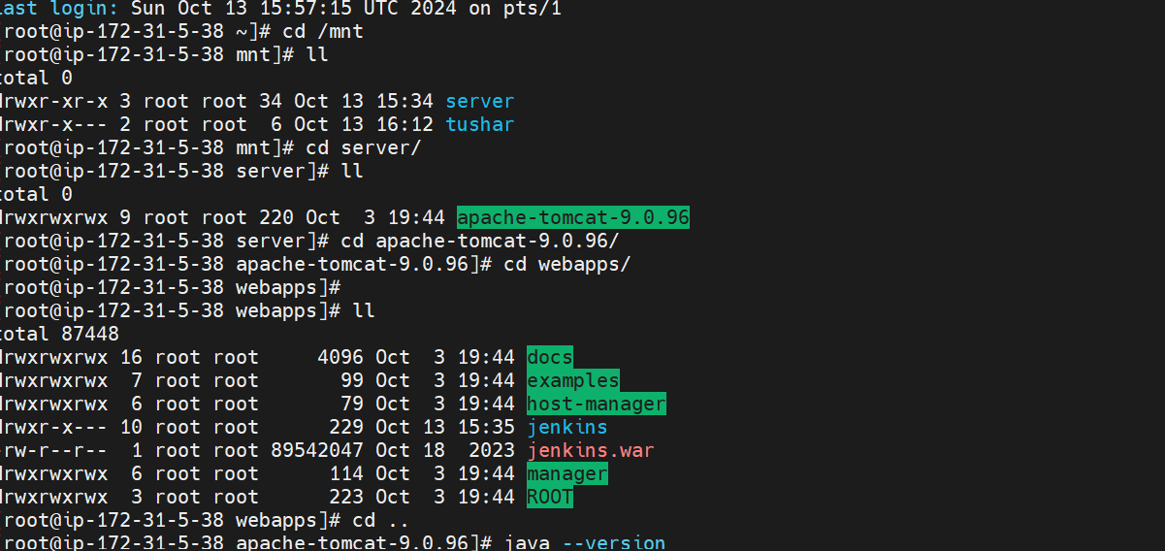

1. Login Jenkins

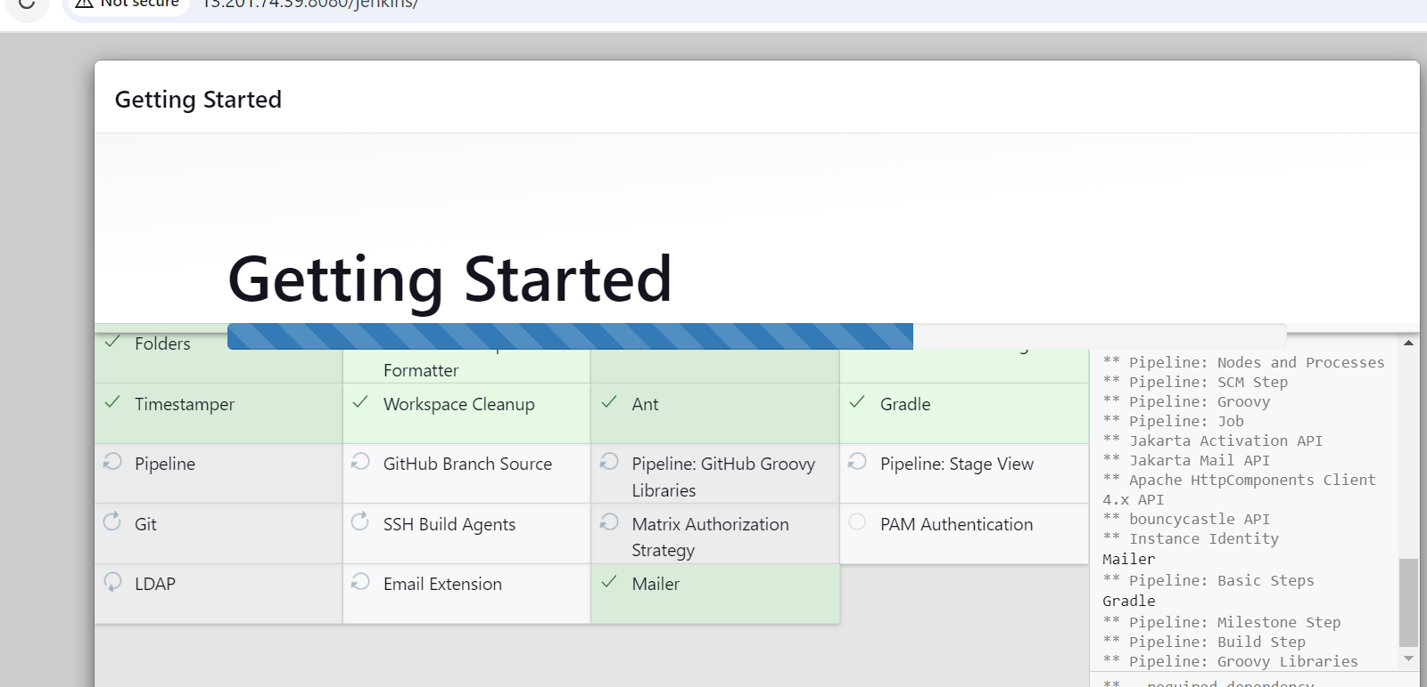

1. Create ec2 instance as JNLP slave

Install java

1. On Jenkins 🡪 go to security 🡪 give fixed TCP ports (8082)
2. Go to Node 🡪 create slave node
3. Configure slave and connect

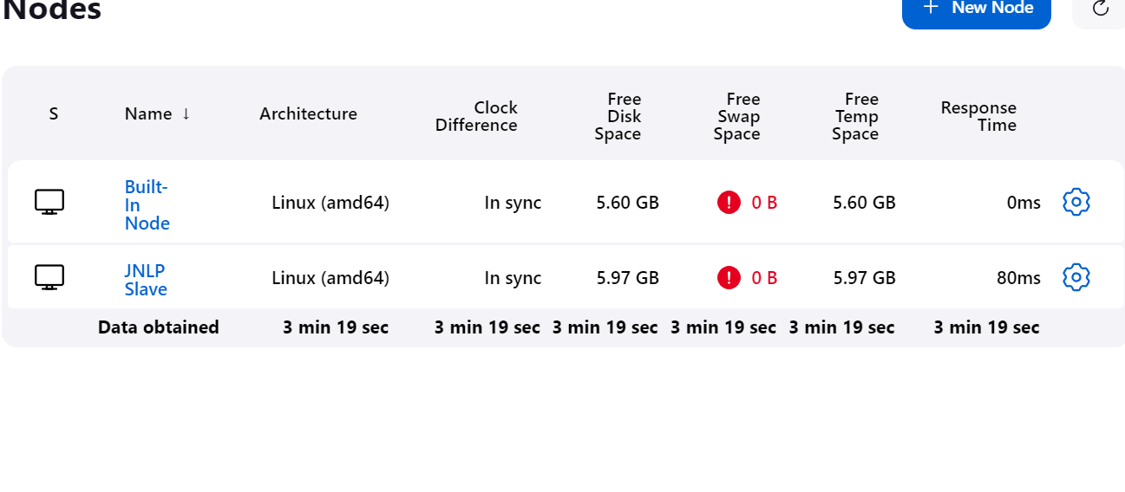

1. Create ec2 instance as SSH slave
2. Go to Node 🡪 create slave node
3. Configure and connect SSH
4. After all Slave connect then login master and create file of private kay name and paste key information

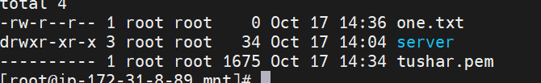

1. Go to both slave and give permission folder where you want copy file from master
2. First time we need copy manually.

**scp -i /mnt/tushar.pem /mnt/one.txt ec2-user@35.154.90.159:/mnt**

1. Then create one job.